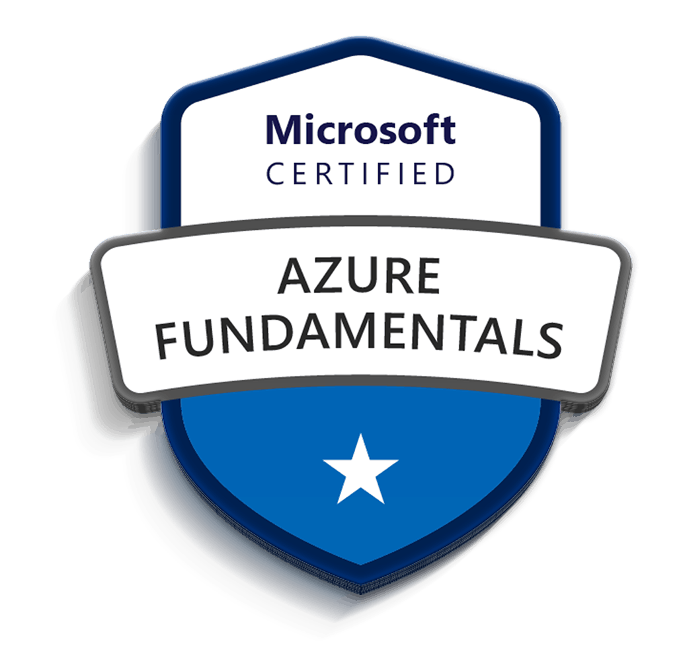
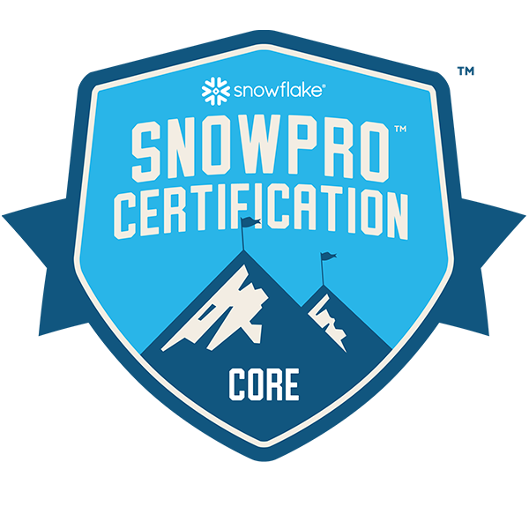
VKUMAR
SENIOR DATA ENGINEER
Ph: 346-396-1166
Email: shravan@talentnine.com
PROFESSIONAL EXPERIENCE:
- Imperative 8+ years of IT experience in all aspects of Bigdata, ETL/ELT, Cloud Database and Migration, business Analytics applications including design, development validation, deployment, reporting & analysis.
- Certified Snowflake SnowPro Core Developer with strong hands-on experience designing, developing, and optimizing Snowflake data models, schemas, and stored procedures for large-scale enterprise data platforms.
- Extensive experience with DBT (Data Build Tool) for modular SQL development, data transformation, testing, and documentation within Snowflake, enabling version-controlled, automated ELT pipelines.
- Designed and implemented orchestrated data pipelines using Apache Airflow, building custom DAGs to automate dependencies, data ingestion, and quality checks across Snowflake and DBT workflows.
- Skilled in writing and tuning complex SQL queries, UDFs, and stored procedures to optimize compute costs, query performance, and warehouse utilization within Snowflake.
- Hands-on experience with ETL/ELT development across cloud ecosystems (AWS, Azure, Databricks), integrating structured and semi-structured data (JSON, Parquet, Avro, CSV).
- Implemented key Snowflake features including Streams, Tasks, Zero-Copy Cloning, Time Travel, Dynamic Data Masking, and Role-Based Access Control (RBAC) to ensure data governance, performance, and recoverability.
- Designed and developed Data Vault and Dimensional Models (Star/Snowflake schemas) in Snowflake to support analytical workloads and BI reporting.
- Experienced in real-time and batch data processing using Spark Structured Streaming, Kafka, Azure Event Hub, and AWS Kinesis.
- Integrated DBT + Airflow + Snowflake pipelines with Python-based frameworks for validation, error handling, and automated deployments via CI/CD (Azure DevOps & GitHub Actions).
- Built and maintained dashboard data models and published datasets for Tableau and Power BI, enabling KPI tracking and advanced analytics.
- Strong background in data quality frameworks, metadata management, and performance tuning across large-scale data platforms.
- Excellent understanding of Spark, Databricks, and Delta Lake, leveraging them for pre-processing and transformation before Snowflake ingestion.
- Experienced in Cloud ecosystem management including provisioning, monitoring, and securing environments across AWS, Azure, and Kubernetes (EKS, AKS).
TECHNICAL SKILLS:

Languages: PySpark, Python, Scala, SQL, PL/SQL, Shell Scripting.
Cloud Technologies: AWS, Snowflake, Azure.
Big data: Cloudera, HDFS, Spark, Kafka, Databricks, Spark Streaming, Azure Data Lake
Databases: Oracle, MY SQL, Snowflake, HBase, Redshift, MangoDB, Azure DW
Data Visualization Tools: Tableau, PowerBI
Scheduling Tools: Crontab, Apache Airflow
Miscellaneous: Teraform, Jenkins, Devops, Artifactory

CERTIFICATIONS:
- Snowflake SnowPro Core certified- 2023
- Microsoft Azure AZ-900 Fundamentals-2020

PROFESSIONAL EXPERIENCE:

Sr.Snowflake Engineer | (Northern Trust| Infosys) | Chicago | June 2024 – Current
Responsibilities:
- Designed and developed end-to-end ELT pipelines using Snowflake, SQL, Python, and Apache Airflow, enabling scalable and automated data transformations across financial, treasury, and operational datasets.
- Built and maintained Snowflake-native transformation layers using optimized SQL, views, and transient tables, implementing reusable, modular transformation logic and data validation frameworks.
- Orchestrated complex data workflows using Apache Airflow, developing DAGs to manage dependencies, automate ingestion, trigger Snowflake transformations, and monitor pipeline health across environments.
- Designed and optimized Snowflake schemas including Star, Snowflake, and Data Vault 2.0, implementing hubs, links, and satellites to support historical tracking, auditability, and data lineage.
- Implemented Snowflake Streams and Tasks for incremental processing and CDC (Change Data Capture), enabling near-real-time data synchronization with minimal latency.
- Developed and optimized Snowflake stored procedures, UDFs, SnowSQL scripts, and Python-based procedures, supporting complex transformations, data quality checks, and business rule enforcement.
- Built batch and near-real-time ingestion pipelines integrating structured and semi-structured data (JSON, CSV, Avro, Parquet) from APIs, RDBMS, and cloud storage into Snowflake.
- Implemented Data Vault 2.0 architecture in Snowflake, enforcing strong data governance, audit controls, and role-based access control (RBAC) across RAW, CURATED, and PUBLISHED layers.
- Leveraged Azure Data Factory (ADF) for source ingestion and orchestration, integrating pipelines with Snowflake and Databricks for scalable data processing.
- Developed Python-based ingestion and validation frameworks to handle schema drift, null checks, duplicate detection, and ingestion error handling before loading into Snowflake.
- Utilized Snowflake Time Travel, Fail-safe, Zero-Copy Cloning, and Secure Views to support data recovery, environment consistency, and safe release management.
- Collaborated with business and security teams to enable Snowflake Secure Data Sharing, Dynamic Data Masking, and Row-Level Security for governed data access.
- Implemented monitoring and observability for Snowflake workloads using Airflow logs, query history, warehouse metrics, and custom operational dashboards.
- Performed Snowflake performance optimization, including query profiling, warehouse right-sizing, clustering strategy design, micro-partition pruning, and compute cost optimization.
- Containerized and deployed ingestion and orchestration components using Docker and Azure Kubernetes Service (AKS), supporting CI/CD and environment parity.
- Integrated Azure Key Vault with Snowflake, Airflow, and ADF to securely manage secrets, credentials, and encryption keys in compliance with enterprise security standards.
Sr.Snowflake Data Engineer(Snowflake|AWS) | Credit Acceptance | Michigan | May 2022 – June 2024

Responsibilities:
- Designed and developed Snowflake-based ELT pipelines orchestrated through Apache Airflow and built with DBT to automate transformation, lineage tracking, and deployment.
- Implemented DBT models and macros for modular SQL development, testing, and documentation, enabling reusable and version-controlled data transformations within Snowflake.
- Developed custom Airflow operators and hooks to trigger DBT runs, Snowflake tasks, and Databricks jobs, integrating upstream and downstream workflows for full pipeline automation.
- Built and optimized Snowflake schemas (Star, Snowflake, and Data Vault 2.0) to support analytics and BI use cases with historical tracking and auditability.
- Implemented incremental loading and CDC using Snowflake Streams + Tasks, improving data freshness and reliability.
- Created and tuned SnowSQL scripts, UDFs, and stored procedures for complex business logic, window functions, and transformation pipelines.
- Automated data ingestion from multiple sources (Oracle, DB2, APIs, flat files) using Snowpipe and COPY INTO commands for both batch and near real-time loading.
- Ensured data governance and security through Role-Based Access Control (RBAC), Row Access Policies, Dynamic Data Masking, and fine-grained warehouse privileges.
- Improved pipeline reliability with error handling, retry logic, and data-quality validation embedded into Airflow DAGs and DBT tests.
- Applied performance tuning via clustering keys, query profiling, pruning, caching, and warehouse optimization to reduce compute cost and latency.
- Designed and developed PySpark applications in Databricks for preprocessing and enrichment of large datasets prior to Snowflake loading.
- Built real-time streaming pipelines integrating Kafka/Event Hub with Structured Streaming for low-latency analytics.
- Developed CI/CD pipelines in Azure DevOps and GitHub Actions to automate build, test, and deployment of Airflow DAGs, DBT models, and Snowflake objects.
- Containerized ETL components using Docker + Kubernetes (EKS) for consistent deployment and scalability.
- Integrated monitoring and alerting with Airflow, CloudWatch, and Snowflake Resource Monitors to track job execution and warehouse usage.
- Collaborated with BI teams to expose curated datasets to Tableau and Power BI, ensuring high-performance analytical queries.

Data Engineer | Health Care Service Corporation | Chicago, IL | May 2021 – April 2022

Responsibilities:
- Analyze and troubleshoot diverse issues within Hadoop ecosystem tools, identify the performance issues, bottlenecks in production environment and recreate complex customer and production reported issues to determine root cause and validate the solution.
- Migrated data from on-premises SQL Database to Azure Synapse Analytics using Azure Data Factory, designed optimized database architecture.
- Created Azure Data Factory for copying data from Azure BLOB storage to SQL Server
- Implement ad-hoc analysis solutions using Azure Data Lake Analytics/Store, HDInsight/Databricks
- Created Reusable ADF pipelines to call REST APIs and consume Kafka Events.
- Implemented Delta Live Tables for real-time data change tracking and processing.
- Leveraged Delta Live Tables for managing and maintaining streaming data sources.
- Performed Kafka analysis, feature selection, feature extraction using Apache Spark Machine.
- SSIS jobs were migrated, and data was transported from Microsoft SQL Server to Snowflake. Utilizing Snow SQL.
- Experienced in migrating Data from Excel, Flat file, Oracle to MS SQL Server using SQL Server Integration Services (SSIS) and expert in Creating, Configuring and Fine-tuning ETL workflows in SSIS.
- Deployed PySpark jobs on AWS infrastructure, optimizing resource allocation and performance for optimal execution of data processing tasks.
- Designed and implemented ETL processes using PySpark to extract, transform, and load data from various sources into target systems, ensuring data quality and integrity.
- Conducted performance tuning and optimization of PySpark applications, identifying and addressing bottlenecks to improve job execution time and resource utilization.
- Used Azure services to query large amount data stored on Blob Storage to create a Virtual Data Lake without having to go through ETL process. Developed ETL processes to move data between RDBMS and NoSQL data storage.
- Implemented continuous integration and deployment (CI/CD) pipelines using GitHub Actions for automated build, test, and deployment processes.
- Skilled in identifying and resolving performance bottlenecks within SSIS packages, optimizing data flow efficiency, tuning database queries, and implementing best practices to enhance overall package performance.
- Collaborated with cross-functional teams to define and implement infrastructure as code (IaC) using Terraform for cloud resources provisioning.
- Implemented custom data processing pipelines using Pandas, combining multiple operations such as filtering, grouping, and aggregation to automate complex data workflows efficiently.
- Utilized NumPy arrays and vectorized operations to perform high-performance numerical computations, accelerating data processing tasks and improving computational efficiency.
- Ensured data consistency and lineage when sharing Delta tables with external entities.
- Integrated Delta Sharing into data architectures for seamless and secure data exchange.
- Implement ad-hoc analysis solutions using Azure Data Lake Analytics/Store, HDInsight/Databricks
- Developing and configuring Build and Release (CI/CD) processes using Azure DevOps, along with managing application code using Azure GIT with required security standards for Spark Framework.
- Created packages in SSIS with error handling as well as created complex SSIS packages using various transformations and tasks like Sequence Containers, for loop and For Each Loop Container, Execute-SQL, Execute Package, Send Mail, File System, Conditional Split, Data Conversion, Derived Column, Lookup, Merge, Merge Join, Row Count, Union All, flat file source and destination, OLE DB source and destination, excel.
- Collaborated with cross-functional teams to leverage Databricks for collaborative data science and analytics projects.
- Exploring with Spark, improving performance and optimization of the existing algorithms in Hadoop using Spark Context, Spark-SQL, Data Frame and Pair RDD's.
Environment: Python, Azure ADLS, Logic Apps, Py-Spark, Hadoop, HDFS, Sqoop, Snowflake, Apache Spark, Spark-SQL, ETL

Data Engineer | Express Scripts | Austin, TX | Dec 2019 – April 2021

Responsibilities:
- Worked closely with executives, senior leadership teams, management and business analysts in business process modeling and mapping, and the understanding of business requirements.
- Proficient in using Databricks Unified Analytics Platform for big data analytics and machine learning.
- Experience in setting up and managing Databricks clusters for scalable data processing.
- Deployed and managed relational databases on Azure Synapse, including MySQL and PostgreSQL.
- Utilized Databricks for exploration data analysis, feature engineering, and model development.
- Developed data pipelines to automate data movement and transformation tasks, reducing manual effort and improving operational efficiency.
- Optimized PySpark configurations, parallelism settings, and caching strategies to enhance job performance and scalability on Azure infrastructure.
- Experience in creating and loading Stages in Azure Blob Storage. Have knowledge of different storage classes and life cycle policy implementation.
- Created SSIS packages for ETL processes by using control flow and data flow components.
- Maintained and tuned performance for slowly running SSIS packages.
- Designed ETL packages dealing with different data sources (SQL Server, Flat Files) and loaded the data into target data sources by performing different kinds of transformations using SQL Server Integration Services (SSIS)
- Designed and implemented data pipelines that utilize Delta Live Tables for seamless data integration.
- Collaborated with data engineering teams to ensure data consistency and reliability using Delta Live Tables.
- Utilized Delta Live Tables to enable collaborative and interactive analytics on streaming data.
- Primarily involved in Data Migration using SQL, SQL Azure, Azure storage, and Azure Data Factory, SSIS.
- Utilized Terraform to automate the deployment and scaling of infrastructure components in cloud environments.
- Managed and optimized the build artifact lifecycle using Artifactory for artifact storage and version control.
- Implemented one time data migration of multistate level data from SQL server to Snowflake by using Py-spark framework.
- Developed shell scripts on Azure CLI for compression with Gzip, backup, transfer to edge node with all necessary file operational requirements for Azure Synapse jobs.
- Developing Tableau data visualization using cross tabs, heat maps, waffle charts, geographic map, pie charts and bar charts, Word cloud, pareto chart etc...
Environment: Py-Spark, Azure, Apache Airflow, Confluence, Hive, HDFS, Azure SSIS, SSRS,IntelliJ, GitHub, Linux, Tableau, PowerBI.

Bigdata Developer | American International Group | Hyderabad, IN | Aug 2017 – July 2019
Responsibilities:
- Involved in data Ingestion on daily basis using Apache Nifi and version management using Nifi registry.
- Hands on experience in Nifi to extract data from file, database, RESTAPI and transform into business Insights. Designed and Developed data integration/engineering workflows on big data technologies and platforms - Hadoop, Spark, MapReduce, Hive, HBase.
- Prepared the content for installation and configuration of Spark using Eclipse and Jupyter Notebook.
- Developed the hands-on exercises in spark using python for all the transformations.
- Designed exercises tasks on using the Parquet File Format with Impala Tables along with queries
- Involved in importing data into HDFS and Hive using Sqoop data from RDBMS and creating external Hive tables, loading with data, and writing Hive queries.
- Developed Hive scripts using HQL to transform and aggregate data for Analytics
- Developed custom Apache Spark programs for data validation to filter unwanted data and cleanse the data. Experienced in handling large data sets using Partitions, Spark in Memory capabilities.
- Developed dataflows and processes for Data processing using SQL (SparkSQL&DataFrames).
- Designed and developed Map Reduce (hive) programs to analyze & evaluate multiple solutions, considering multiple cost factors across the business as well operational impact. Involved in setting up Hortonworks cluster to configure tune Map Reduce and YARN parameters to run Sqoop and Map Reduce jobs effectively
- Involved defining RDD structures for core spark and Data frame based SQL processing in Spark SQL
- Working on Hive Meta store backup, Partitioning, and bucketing techniques in Hive to improve the performance.
Environment: Spark, Python, Sqoop, Hive, Hadoop, SQL, HBase, MapReduce, HDFS, Oozie, Agile, Apache NiFi
EDUCATION:
Master of Science, Computational Data Science.
Kent State University | USA.
Bachelor of Science, Computer Science
JBIT University | India.

